**Chess Engine**

**https://github.com/comp195/senior-project-spring-2023-chess-engine-classic-chess-game.git**

**Robert Kelly (r_kelly5@u.pacific.edu)**

**Lorena Aguilera (l_aguilera2@u.pacific.edu)**

**Paxton O’Bryan (p_obryan@u.pacific.edu)**

**Last Revision: 5/5/2023**

**Overview**

Our goal in this senior design project was to create a single player chess game that can be played anywhere on the go from the comfort of a computer. This game was split into two main elements. The first element was the user interface of the project. Using the Windows API, we created a board to move pieces, represent the moves of the player, and to represent the moves of the engine. The second element was to create the chess engine itself along with player move validation, which took into account the state of the board, making decisions accordingly with validation.

**System Architecture**

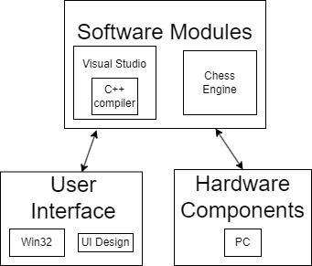

**Hardware, Software and System Requirements**

The game is functionable on any modern computer with the game file. No extra hardware or software is needed.

**Software Design**

**Class Diagram**

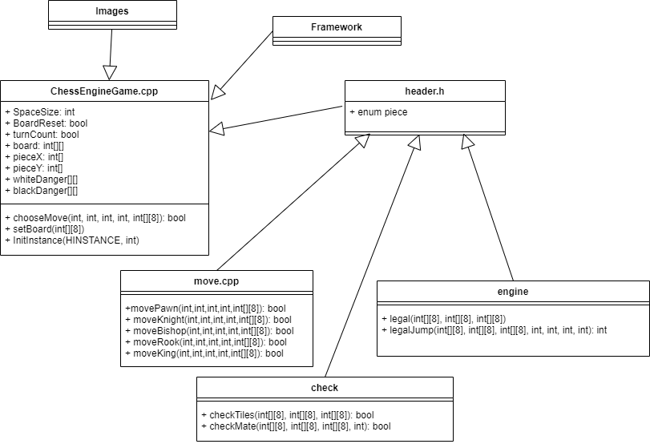

**Interaction Diagrams**

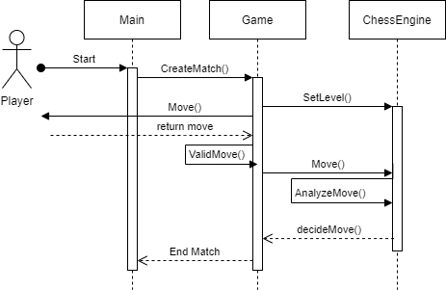

**Design Consideration**

**User Interface Design**

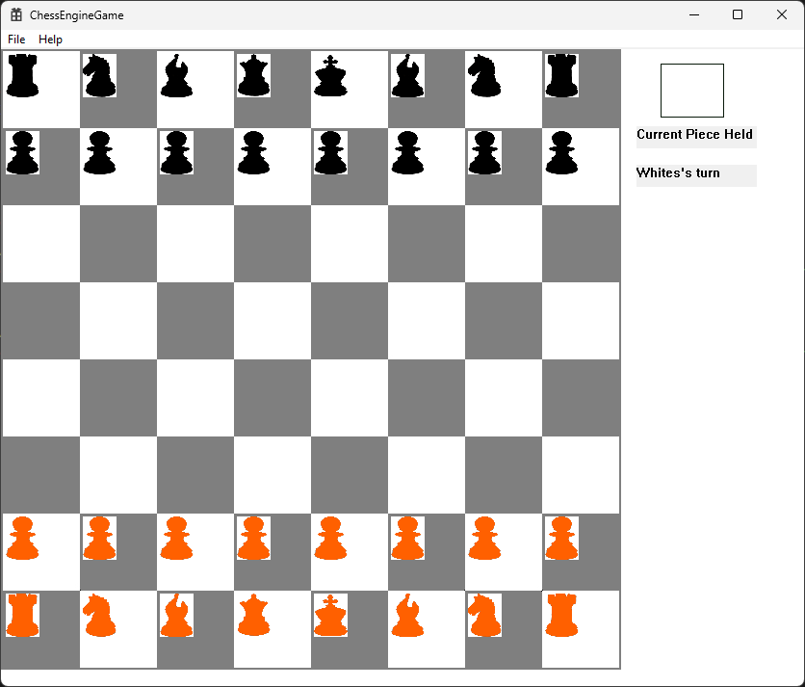

* Pieces for the 2 separate teams, orange and black
* Checkerboard pattern to indicate where pieces can be placed.
* Box appearing to indicate current piece held by player
* If illegal move is done, piece will return to original position